**Stoichiometric Characterization of Compounds and Mixtures**

24 September 2023

CHEM 1310L Laboratory

*Introduction*

Stoichiometry is a branch of chemistry regarding the molar ratios of molecules during chemical reactions. In the context of performing experiments, we can utilize stoichiometric ratios and dimensional analysis to carry out chemical reactions in accurate molecular ratios by converting between our standard unit of measurement, grams, and what reactions are measured in, moles.

Sodium percarbonate is the active ingredient in many chemical cleaners. During production, sodium percarbonate is bonded to two hydrogen peroxide molecules. However, over time, the degradation of sodium percarbonate is attributed to the loss of hydrogen peroxide molecules bonded to sodium percarbonate. By titrating known concentrations of sodium thiosulfate with the unknown concentrations of a mixture containing sodium percarbonate, we can easily deduce the ratio of hydrogen peroxide molecules bonded to sodium percarbonate molecules. Because degradation over time reduces from 2 to 1 as its ratio, the molar ratio between sodium carbonate and hydrogen peroxide will be roughly 1:1.5.

Specifically, in part A of the experiment, we prepare a solution of sodium percarbonate and potassium iodide by mixing it with sulfuric acid to dismember the ions from each other. We then titrate the mixture with sodium thiosulfate until we notice a distinct color change. At this point, the triiodide has turned to regular iodide ions; since iodide is in a 1:1 molar ratio with hydrogen peroxide, we can determine the amount of moles of hydrogen peroxide and easily figure out the ratio as first intended.

A similar approach is taken for part B of this experiment where we need to determine the composition by mass of sodium chloride and sodium nitrate. We first dissolve the salts in water and add an indicator of potassium chromate to the solution. We then slowly titrate in silver ions into the solution until it turns a slight orange color, a sign that the chromate indicator has bonded to silver ions and chloride has run out. The upper limit of sodium chloride is expected to be proportional to the amount of silver ions titrated into the solution of around 30% by mass.

*Data and Results*

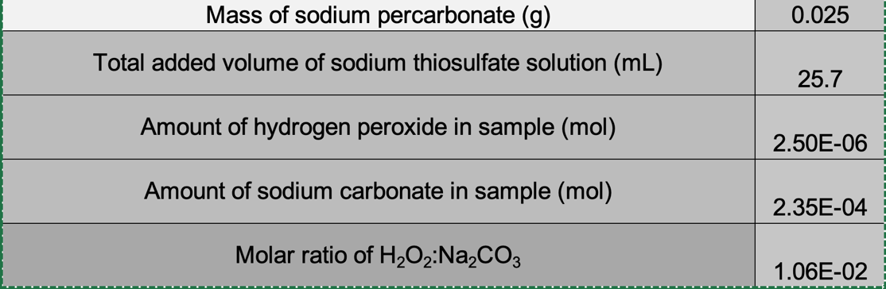

**Table 1.** Measurement of H2O2:Na2CO3 molar ratio in sodium percarbonate.

**Table 2.** Measurement of the mass percentage of NaCl in a mixture of NaCl and NaNO3.

**Figure 1.** Mass percentages of sodium, chlorine, nitrogen, and oxygen in the studied mixture.

*Discussion*

During part A of this experiment, we deduced the ratio of hydrogen peroxide to sodium percarbonate by a series of reactions that involved the stoichiometric ratios of molecules in relation with iodide and triiodide. Specifically, we first mixed together potassium iodide and sodium carbonate in sulfuric acid to make triiodide, which is derived from the reaction of hydrogen peroxide and iodide. Below, the series of equations help illustrate the said reaction.

*Sodium Carbonate first dissolved in water to get aqueous Hydrogen Peroxide*

$$Na_{2}CO_{3} ∙n H_{2}O_{2}\left(s\right)→2Na^{+}\left(aq\right)+{{CO}_{3}}^{2-}\left(aq\right)+n H_{2}O_{2}(aq)$$

*Aqueous hydrogen peroxide reacts with iodide ions (potassium iodide dissolved with sulfuric acid) to form triiodide.*

$$H_{2}O_{2}\left(aq\right) +2H^{+}\left(aq\right) +3I^{-}(aq)→2H_{2}O\left(l\right)+ {I_{3}}^{-}(aq)$$

With a prepared solution of unknown amounts of triiodide, we can use the following chemical reaction to revert triiodide back to iodine with sodium thiosulfate.

$${I_{3}}^{-}\left(aq\right) +2S_{2}{O_{3}}^{2-}\left(aq\right)→3I^{-}\left(aq\right)+S_{4}{O_{6}}^{2-}\left(aq\right)$$

We do this by titrating in specific amounts of sodium thiosulfate and measuring the exact amount of thiosulfate added until a color change has occurred; in other words, until we run out of triiodide. Because we needed to add 0.000005 mols of sodium thiosulfate, we can figure out the amount of hydrogen peroxide as follows based on the stoichiometry of the chemical reactions described above.

$$\frac{\left(.1 M\right)\left(.0257- .02565\right) mol {S_{2}O_{3}}^{2-}}{1} × \frac{1 mol {I_{3}}^{-}}{2 mol {S_{2}O_{3}}^{2-}} × \frac{1 mol H_{2}O_{2}}{1 mol {I_{3}}^{-}}$$

We now know the moles of hydrogen peroxide, but we still need the amount of moles of sodium carbonate. To do this, we can convert the number of moles of hydrogen peroxide to its mass in grams and subtract that mass from .025 to determine the mass of sodium percarbonate which can be divided by its molar mass to get its number of moles. Described as follows:

$$.000005 mols H_{2}O_{2} ×\frac{34.0417 g H_{2}O_{2}}{1 mol H_{2}O_{2}}=8.5036 *{10}^{-5}g H_{2}O_{2}$$

$$.025-8.5036 *{10}^{-5}=0.024914 g Na_{2}CO_{3}$$

$$0.024914 g Na_{2}CO_{3} ×\frac{1 mol Na_{2}CO_{3} }{105.99 g Na_{2}CO_{3}}=2.315∙{10}^{-4} mol Na_{2}CO_{3}$$

The ratio n is calculated as follows:

$$n= \frac{.000005 mols H_{2}O_{2}}{2.315∙{10}^{-4} mol Na_{2}CO_{3}}= .0106$$

For part B of this experiment, we follow a similar approach to figure out the composition of sodium chloride and sodium nitrate from the unknown mixture of the two and were able to figure out the mass composition of each of the elements from that mixture. We begin this experiment by dissolving the unknown solids in water to dissociate the ions of sodium, chloride, and nitrate. The following equation describes the process.

*Dissociation of sodium chloride and sodium nitrate in water.*

$$NaCl \left(s\right)+NaNO_{3}\left(s\right)→2Na^{+}\left(aq\right)+{Cl}^{-}\left(aq\right)+N{O_{3}}^{-}(aq)$$

*Addition of dissociated potassium chromate as silver indicator. Chromate serves as an indicator of silver because silver (II) chromate turns orange.*

$$NaCl \left(s\right)+NaNO_{3}\left(s\right) +K_{2}CrO_{4}\left(s\right)→2Na^{+}\left(aq\right)+{Cl}^{-}\left(aq\right)+N{O_{3}}^{-}\left(aq\right)+K^{+}\left(aq\right)+ {CrO_{4}}^{2-}(aq)$$

When titrating in silver to the dissociated ions, silver first binds with chlorine ions because silver chloride has a lower solubility than silver (II) chromate. As such, when the solution turns orange indicating the beginning of silver (II) chromate forming, we know chloride has been completely exhausted. By measuring the amount of silver titrated, we determine the amount of chloride initially in the solution and thus the amount of sodium chloride in the solution. If we titrated 1.732 grams of 1.7% silver nitrate, the following conversions illustrate how to determine the amount of sodium chloride.

$$\left(1.732\right)\left(.017\right) g AgNO_{3} × \frac{1 mol AgNO_{3}}{169.87 g AgNO_{3}} × \frac{1 mol Cl^{-}}{1 mol AgNO_{3}} × \frac{1 mol NaCl}{1 mol Cl^{-}}=1.733 ∙10^{-4} mol NaCl$$

$$1.733 ∙10^{-4} mol NaCl×\frac{58.44 g NaCl}{1 mol NaCl} = .0101295 g NaCl$$

As such, the unknown solid mixture contained 20.59% Sodium Chloride by mass.